1. Intellij has a powerful feature called “**Class Level Watch**”.
2. **Class Level Watch**: Class Level Watch appears as on top of the class where we create a watch.  
   The value of this field depends on the expression we provide.  
   **Jatin**: Actually, class level watch is nothing but additional field added to the class during debugging & when we define these watch, we provide an expression based on which the value for that field (class level watch) is calculated.
3. 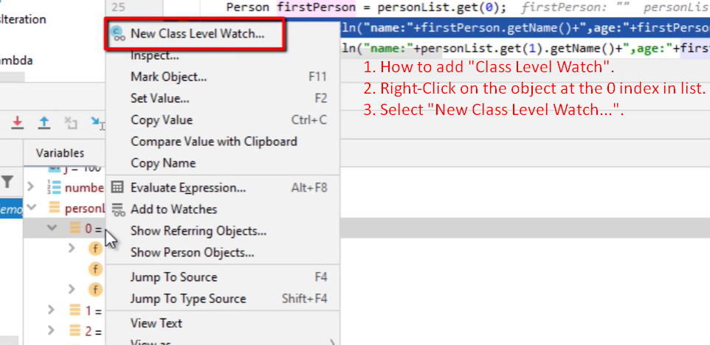
4. 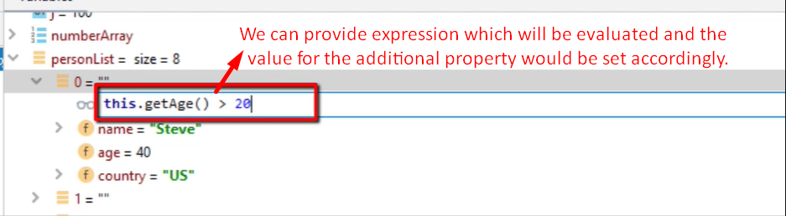
5. 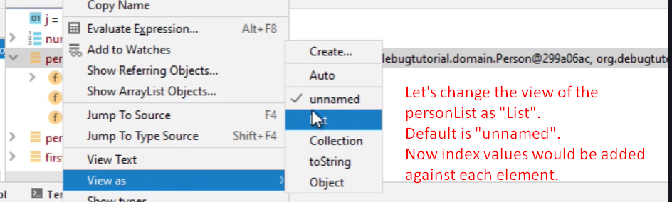
6. In the following slide, you can see a dynamic property to the class is added & its value is calculated based on the given expression.  
   